Artery Research
Online Data Supplement
This supplement formed part of the original submission and has been peer reviewed.
We posted it as supplied by the authors. Supplement to: Central versus Peripheral Blood Pressure Components as Determinants of Retinal Microvessel Diameters. Artery Res 2014.

Table S1 Relation of retinal vessel diameters with peripheral blood pressure components excluding patients on antihypertensive drug treatment
Independent variables | Central retinal arteriolar equivalent |  |  |  |  | Central retinal venular equivalent
Independent variables | β (95% CI) | r2 | p | VIF |  | β (95% CI) | r2 | p | VIF
Single blood pressure component
Systolic pressure (mmHg) | –3.80 (–4.94 to –2.65) | 0.071 | <0.0001 | 1.23 |  | –2.04 (–3.76 to –0.33) | 0.011 | 0.023 | 1.23
Diastolic pressure (mmHg) | –3.35 (–4.62 to –2.07) | 0.053 | <0.0001 | 1.23 |  | –0.84 (–2.66 to 0.98) | 0.002 | 0.39 | 1.23
Mean pressure (mmHg) | –4.00 (–5.18 to –2.82) | 0.077 | <0.0001 | 1.27 |  | –1.60 (–3.56 to 0.36) | 0.006 | 0.10 | 1.27
Pulse pressure (mmHg) | –2.02 (–3.33 to –0.70) | 0.022 | 0.001 | 1.11 |  | –1.90 (–3.66 to –0.15) | 0.009 | 0.040 | 1.11
Two blood pressure components
Model 1
Systolic pressure (mmHg) | –2.92 (–4.35 to –1.49) | 0.028 | 0.0004 | 1.88 |  | –2.48 (–4.77 to –0.19) | 0.010 | 0.035 | 1.88
Diastolic pressure (mmHg) | –1.67 (–3.31 to –0.03) | 0.009 | 0.043 | 1.89 |  | 0.65 (–1.72 to 3.02) | <0.001 | 0.58 | 1.89
Model 2
Mean pressure (mmHg) | –3.70 (–5.07 to –2.33) | 0.059 | <0.0001 | 1.44 |  | –1.00 (–2.96 to 0.96) | 0.002 | 0.33 | 1.44
Pulse pressure (mmHg) | –0.78 (–2.10 to 0.53) | 0.003 | 0.21 | 1.26 |  | –1.57 (–3.32 to 0.19) | 0.006 | 0.11 | 1.26
All models were adjusted for sex, age, body mass index, smoking and drinking, ratio of HDL-to-total serum cholesterol, and antihypertensive drug treatment. β (95% confidence interval), r2, and p, indicate effect size (95% confidence interval), the squared partial correlation coefficient, and significance, respectively. Effect sizes express the change in central retinal arteriolar or venular equivalent associated with a 1–SD increase in the blood pressure component. SDs were 14.6 mmHg, 9.3 mmHg, 10.0 mmHg, and 11.2 mmHg for systolic, diastolic, mean arterial pressure and pulse pressure, respectively. VIF indicates the variance inflation factor.

Table S2 Relation of retinal vessel diameters with central blood pressure components excluding patients on antihypertensive drug treatment
Independent variables | Central retinal arteriolar equivalent |  |  |  |  | Central retinal venular equivalent
Independent variables | β (95% CI) | r2 | p | VIF |  | β (95% CI) | r2 | p | VIF
Single blood pressure component
Systolic pressure (mmHg) | –3.54 (–4.75 to –2.33) | 0.057 | <0.0001 | 1.29 |  | –1.86 (–3.76 to 0.04) | 0.008 | 0.057 | 1.29
Diastolic pressure (mmHg) | –3.32 (–4.63 to –2.02) | 0.052 | <0.0001 | 1.22 |  | –0.76 (–2.62 to 1.10) | 0.001 | 0.40 | 1.23
Mean pressure (mmHg) | –3.74 (–5.00 to –2.49) | 0.068 | <0.0001 | 1.23 |  | –1.28 (–3.17 to 0.60) | 0.006 | 0.19 | 1.27
Pulse pressure (mmHg) | –1.59 (–2.78 to –0.39) | 0.013 | 0.001 | 1.19 |  | –1.59 (–3.45 to 0.33) | 0.009 | 0.09 | 1.11
Two blood pressure components
Model 1
Systolic pressure (mmHg) | –2.31 (–3.82 to –0.809) | 0.018 | 0.004 | 1.93 |  | –2.00 (–4.42 to 0.41) | 0.007 | 0.08 | 1.93
Diastolic pressure (mmHg) | –1.99 (–3.48 to –0.50) | 0.013 | 0.013 | 1.83 |  | 0.38 (–1.85 to 2.61) | <0.001 | 0.75 | 1.83
Model 2
Mean pressure (mmHg) | –3.74 (–5.21 to –2.28) | 0.056 | <0.0001 | 1.50 |  | –0.64 (–2.74 to 1.45) | <0.001 | 0.52 | 1.50
Pulse pressure (mmHg) | –0.06 (–1.49 to 1.37) | <0.001 | 0.92 | 1.45 |  | –1.34 (–3.25 to 0.57) | 0.003 | 0.21 | 1.45
All models were adjusted for sex, age, body mass index, smoking and drinking, ratio of HDL-to-total serum cholesterol, and antihypertensive drug treatment. β (95% confidence interval), r2, and p, indicate effect size (95% confidence interval), the squared partial correlation coefficient, and significance, respectively. Effect sizes express the change in central retinal arteriolar or venular equivalent associated with a 1–SD increase in the blood pressure component. SDs were 15.4 mmHg, 9.5 mmHg, 10.7 mmHg, and 12.2 mmHg for systolic, diastolic, mean arterial pressure and pulse pressure, respectively. VIF indicates the variance inflation factor.

Table S3 Relation of retinal vessel diameters with peripheral blood pressure components with further adjustment for fellow vessel diameter
Independent variables | Central retinal arteriolar equivalent |  |  |  |  | Central retinal venular equivalent
Independent variables | β (95% CI) | r2 | p | VIF |  | β (95% CI) | r2 | p | VIF
Single blood pressure component
Systolic pressure (mmHg) | –3.11 (–4.13 to –2.08) | 0.065 | <0.0001 | 1.24 |  | 1.26 (–0.29 to 2.81) | 0.005 | 0.11 | 1.32
Diastolic pressure (mmHg) | –2.82 (–3.83 to –1.81) | 0.056 | <0.0001 | 1.19 |  | 1.66 (0.15 to 3.17) | 0.009 | 0.031 | 1.25
Mean pressure (mmHg) | –3.37 (–3.39 to –2.35) | 0.076 | <0.0001 | 1.23 |  | 1.73 (0.17 to 3.29) | 0.009 | 0.030 | 1.32
Pulse pressure (mmHg) | –1.53 (–2.56 to –0.50) | 0.017 | 0.004 | 1.18 |  | 0.21 (–1.28 to 1.69) | <0.001 | 0.79 | 1.20
Two blood pressure components
Model 1
Systolic pressure (mmHg) | –2.17 (–3.41 to –0.93) | 0.023 | 0.0006 | 1.82 |  | 0.48 (–1.36 to 3.32) | <0.001 | 0.61 | 1.86
Diastolic pressure (mmHg) | –1.61 (–2.82 to –0.40) | 0.013 | 0.009 | 1.76 |  | 1.41 (–0.39 to 3.20) | 0.005 | 0.12 | 1.77
Model 2
Mean pressure (mmHg) | –3.20 (–4.29 to –2.12) | 0.062 | <0.0001 | 1.39 |  | 1.85 (0.20 to 3.50) | 0.009 | 0.028 | 1.47
Pulse pressure (mmHg) | –0.46 (–1.53 to 0.59) | 0.001 | 0.39 | 1.33 |  | –0.36 (–1.92 to 1.21) | <0.001 | 0.65 | 1.33
All models were adjusted for sex, age, body mass index, smoking and drinking, ratio of HDL-to-total serum cholesterol, antihypertensive drug treatment and fellow vessel diameter. Models with central retinal arterial equivalent (CRAE) as dependent variable included central retinal venular equivalent (CRVE) as covariable and vice versa. β (95% confidence interval), r2, and p, indicate effect size (95% confidence interval), the squared partial correlation coefficient, and significance, respectively. Effect sizes express the change in CRAE or CRVE associated with a 1–SD increase in the blood pressure component. SDs were 15.1 mmHg, 9.3 mmHg, 10.1 mmHg, and 12.2 mmHg for systolic, diastolic, mean arterial pressure and pulse pressure, respectively. VIF indicates the variance inflation factor.

Table S4 Relation of retinal vessel diameters with central blood pressure components with further adjustment for fellow vessel diameter
Independent variables | Central retinal arteriolar equivalent |  |  |  |  | Central retinal venular equivalent
Independent variables | β (95% CI) | r2 | p | VIF |  | β (95% CI) | r2 | p | VIF
Single blood pressure component
Systolic pressure (mmHg) | –2.96 (–4.02 to –1.90) | 0.056 | <0.0001 | 1.30 |  | 1.23 (–0.35 to 2.82) | 0.004 | 0.13 | 1.37
Diastolic pressure (mmHg) | –2.82 (–3.82 to –1.82) | 0.057 | <0.0001 | 1.18 |  | 1.68 (0.19 to 3.18) | 0.009 | 0.028 | 1.24
Mean pressure (mmHg) | –3.21 (–4.21 to –2.21) | 0.073 | <0.0001 | 1.19 |  | 1.77 (–0.25 to 3.29) | 0.010 | 0.023 | 1.27
Pulse pressure (mmHg) | –1.32 (–2.39 to –0.25) | 0.011 | 0.016 | 1.27 |  | 0.13 (–1.41 to 1.67) | <0.001 | 0.87 | 1.28
Two blood pressure components
Model 1
Systolic pressure (mmHg) | –1.88 (–3.15 to –0.61) | 0.016 | 0.004 | 1.91 |  | 0.38 (–1.51 to 2.26) | <0.001 | 0.69 | 1.94
Diastolic pressure (mmHg) | –1.81 (–3.01 to –0.60) | 0.017 | 0.003 | 1.74 |  | 1.49 (–0.29 to 3.27) | 0.005 | 0.10 | 1.76
Model 2
Mean pressure (mmHg) | –3.25 (–4.35 to –2.14) | 0.062 | <0.0001 | 1.45 |  | 2.06 (0.39 to 3.72) | 0.011 | 0.016 | 1.53
Pulse pressure (mmHg) | 0.09 (–1.05 to 1.24) | <0.001 | 0.87 | 1.54 |  | –0.71 (–2.39 to 0.97) | 0.001 | 0.40 | 1.54
All models were adjusted for sex, age, body mass index, smoking and drinking, ratio of HDL-to-total serum cholesterol, antihypertensive drug treatment and fellow vessel diameter. Models with central retinal arterial equivalent (CRAE) as dependent variable included central retinal venular equivalent (CRVE) as covariable and vice versa. β (95% confidence interval), r2, and p, indicate effect size (95% confidence interval), the squared partial correlation coefficient, and significance, respectively. Effect sizes express the change in CRAE or CRVE associated with a 1–SD increase in the blood pressure component. SDs were 16.0 mmHg, 9.5 mmHg, 10.7 mmHg, and 13.1 mmHg for systolic, diastolic, mean arterial pressure and pulse pressure, respectively. VIF indicates the variance inflation factor.

Legends to the Figures in Supplement
Figure S1 Central retinal venular equivalent across increasing quartiles of systolic (A), diastolic (B), mean (C) and pulse (D) pressure, as measured peripherally () or centrally (O) in 514 participants (261 women and 253 men). P values denote the significance of linear trend. None of the sex-by-trend interaction terms reached significance (p≥0.48).
Figure S2 Regression slopes of the central retinal venular equivalent on systolic (A), diastolic (B), mean (C) and pulse (D) pressure) on peripheral (——) and central (……) measurement. All models were adjusted for sex, age, body mass index, smoking and drinking, ratio of HDL-to-total serum cholesterol, and antihypertensive drug treatment. P values denote the significance of the difference in slope between peripheral and central blood pressure.
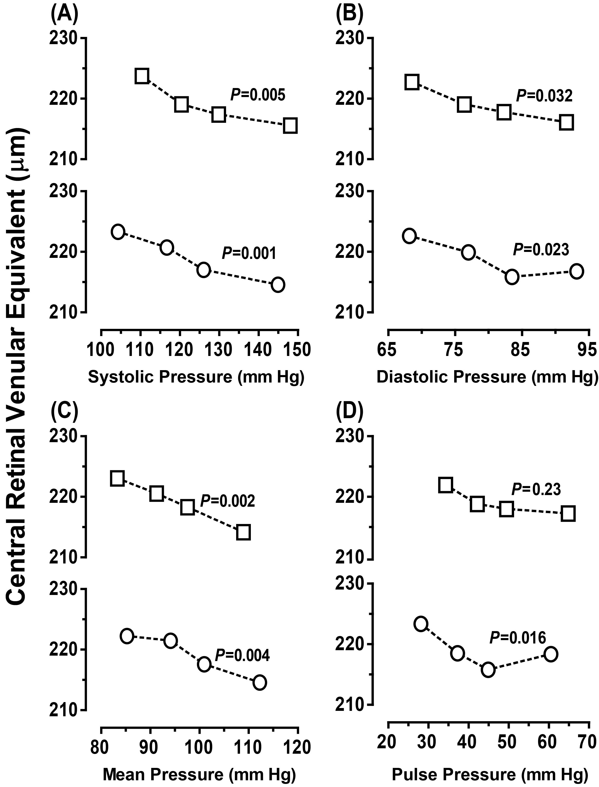

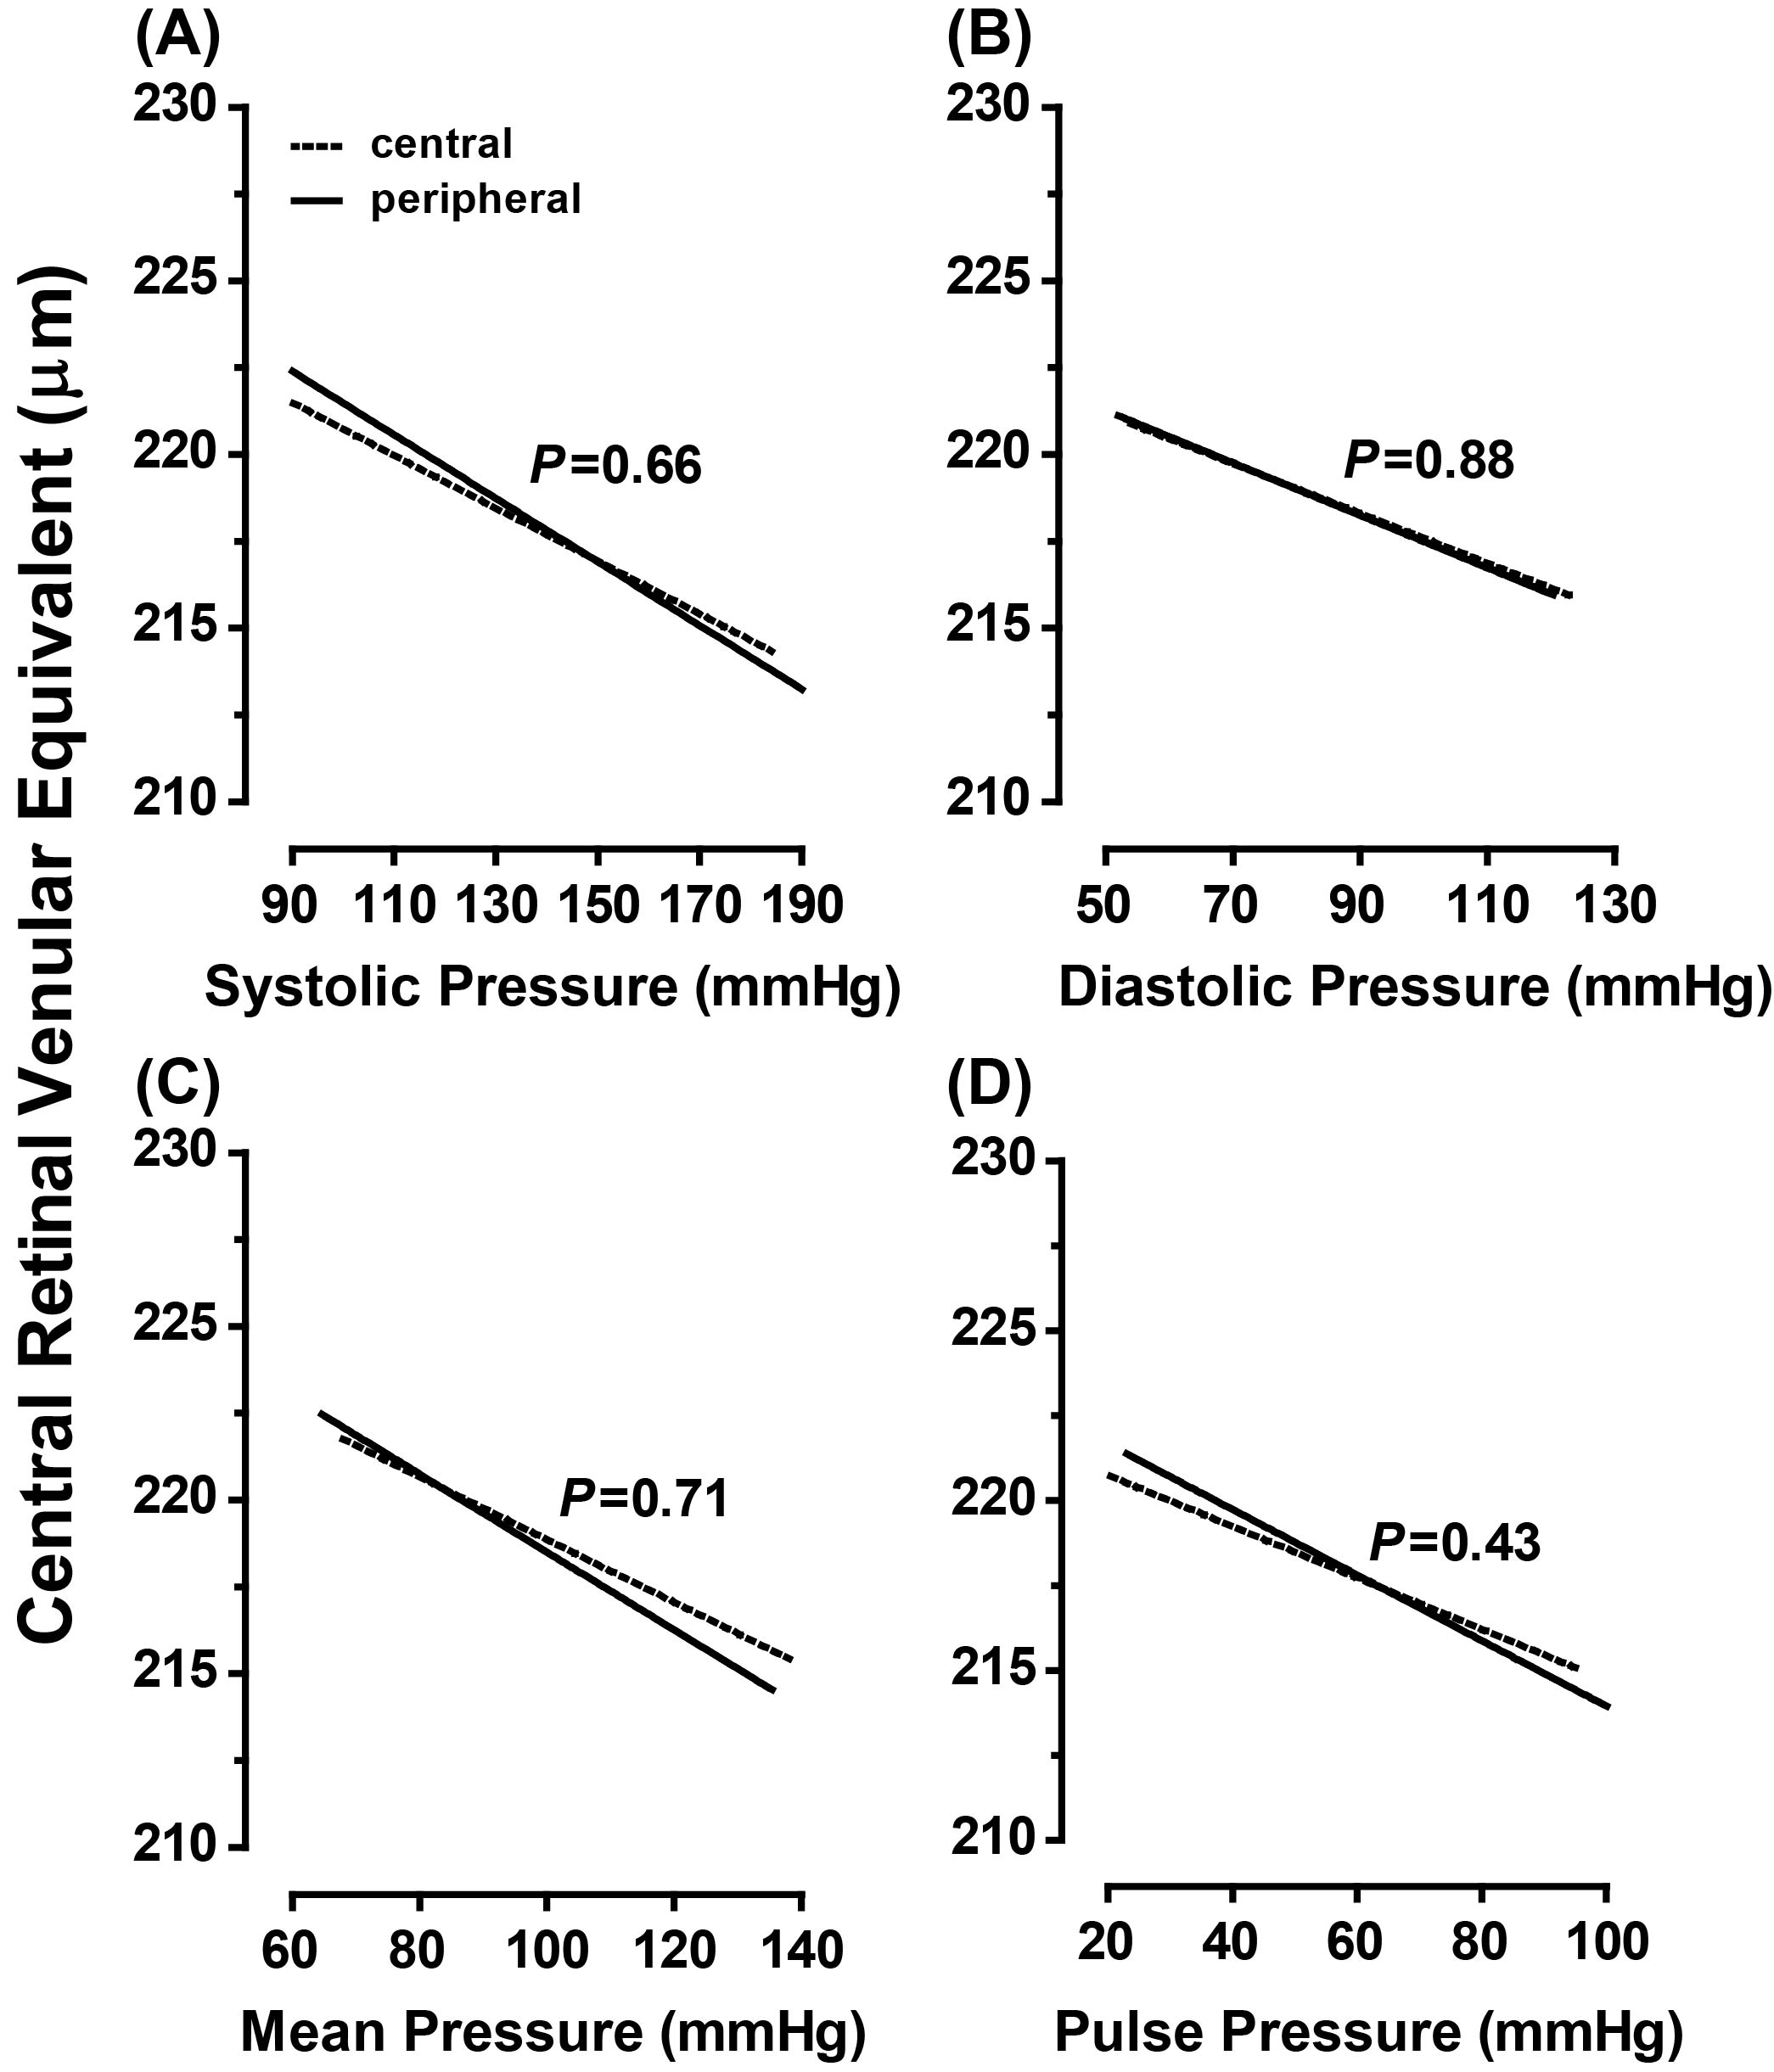
Figure S1 Central retinal venular equivalent across increasing quartiles of systolic (A), diastolic (B), mean (C) and pulse (D) pressure, as measured peripherally () or centrally (O) in 514 participants (261 women and 253 men). P values denote the significance of linear trend. None of the sex-by-trend interaction terms reached significance (p≥0.48).

Figure S2 Regression slopes of the central retinal venular equivalent on systolic (A), diastolic (B), mean (C) and pulse (D) pressure) on peripheral (——) and central (……) measurement. All models were adjusted for sex, age, body mass index, smoking and drinking, ratio of HDL-to-total serum cholesterol, and antihypertensive drug treatment. P values denote the significance of the difference in slope between peripheral and central blood pressure.

