Supporting information for
Combination of microwave, ultrasonic, enzyme assisted method for curcumin species extraction from turmeric (Curcuma longa L.) and evaluation of their antioxidant activity
Chengke Wang∗, Hanli Yang, Jiangyu Li
College of Food and Biological Engineering, Jiangsu University, Zhenjiang 212013, P. R. China

∗Corresponding author: Chengke Wang

Phone (Fax): +86 511 88780201

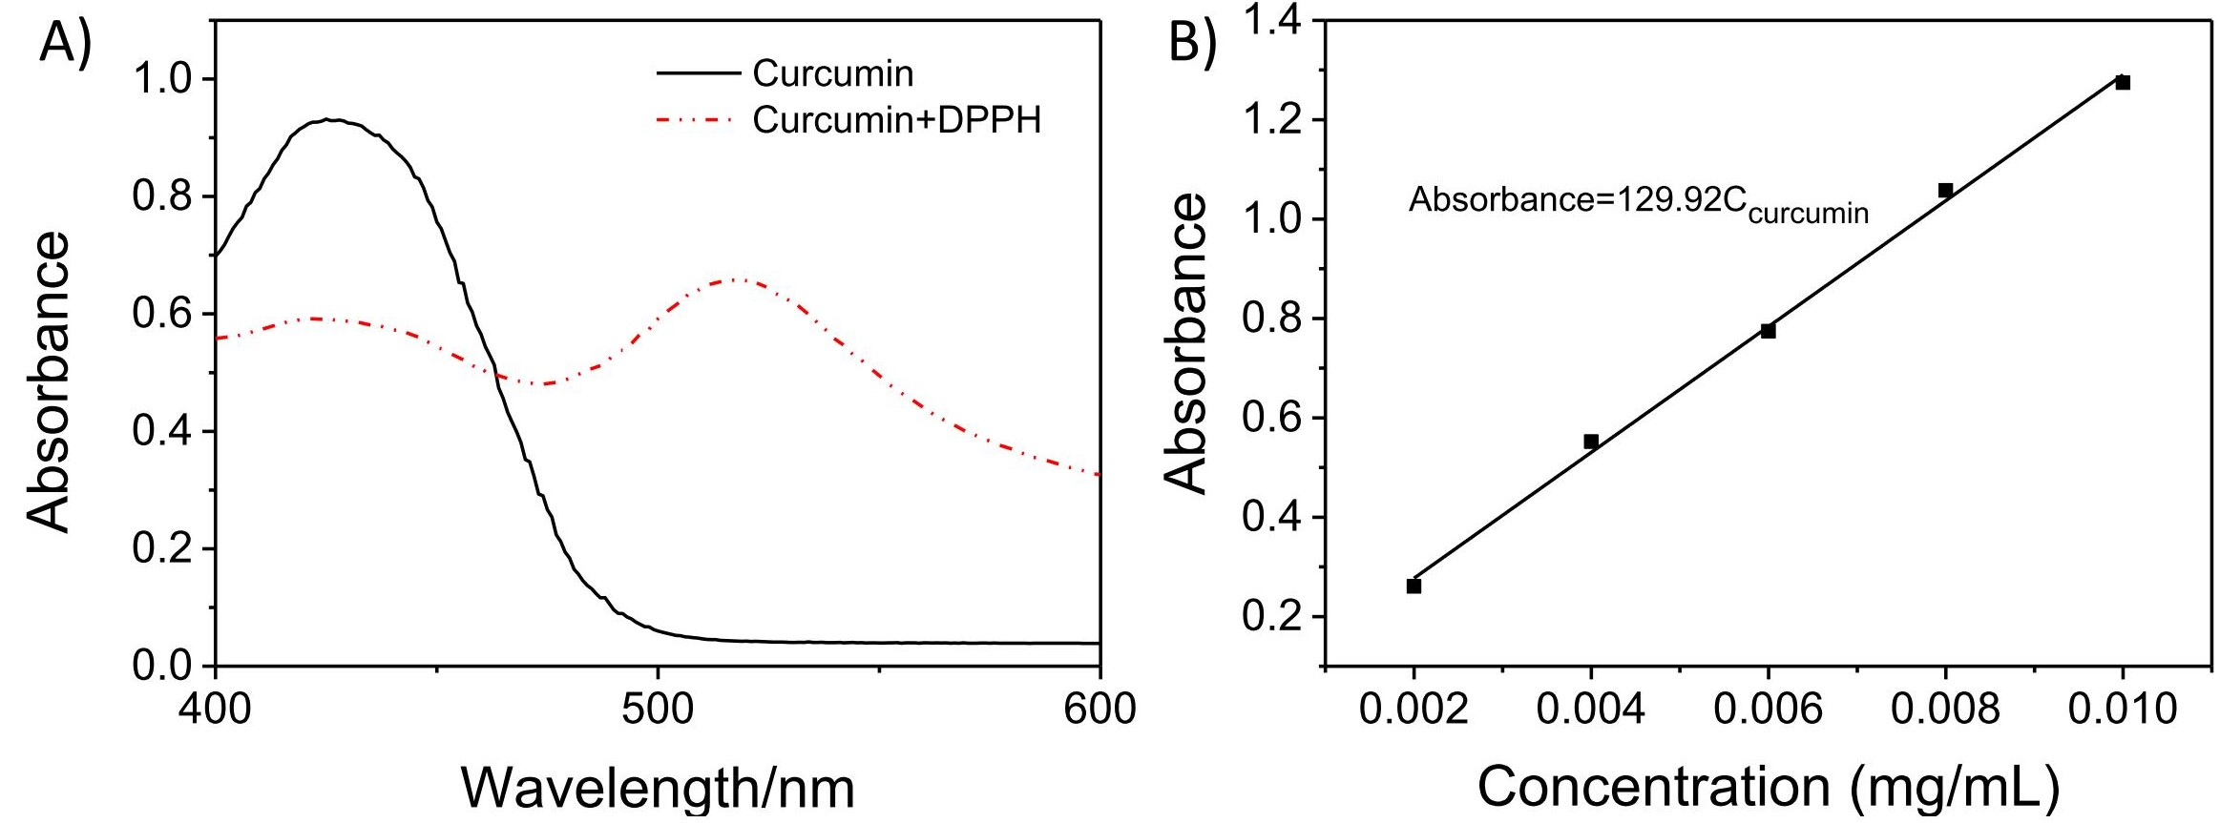
Figure S1. The absorption spectra of curcumin in the absence and presence of DPPH. The absorption spectra of curcumin (black, solid line) and curcumin with DPPH (red, dot line) (A) and the calibration standard curve of curcumin (B). The concentrations of curcumin and DPPH are 7 mg/L and 31.25 mg/mL, respectively.
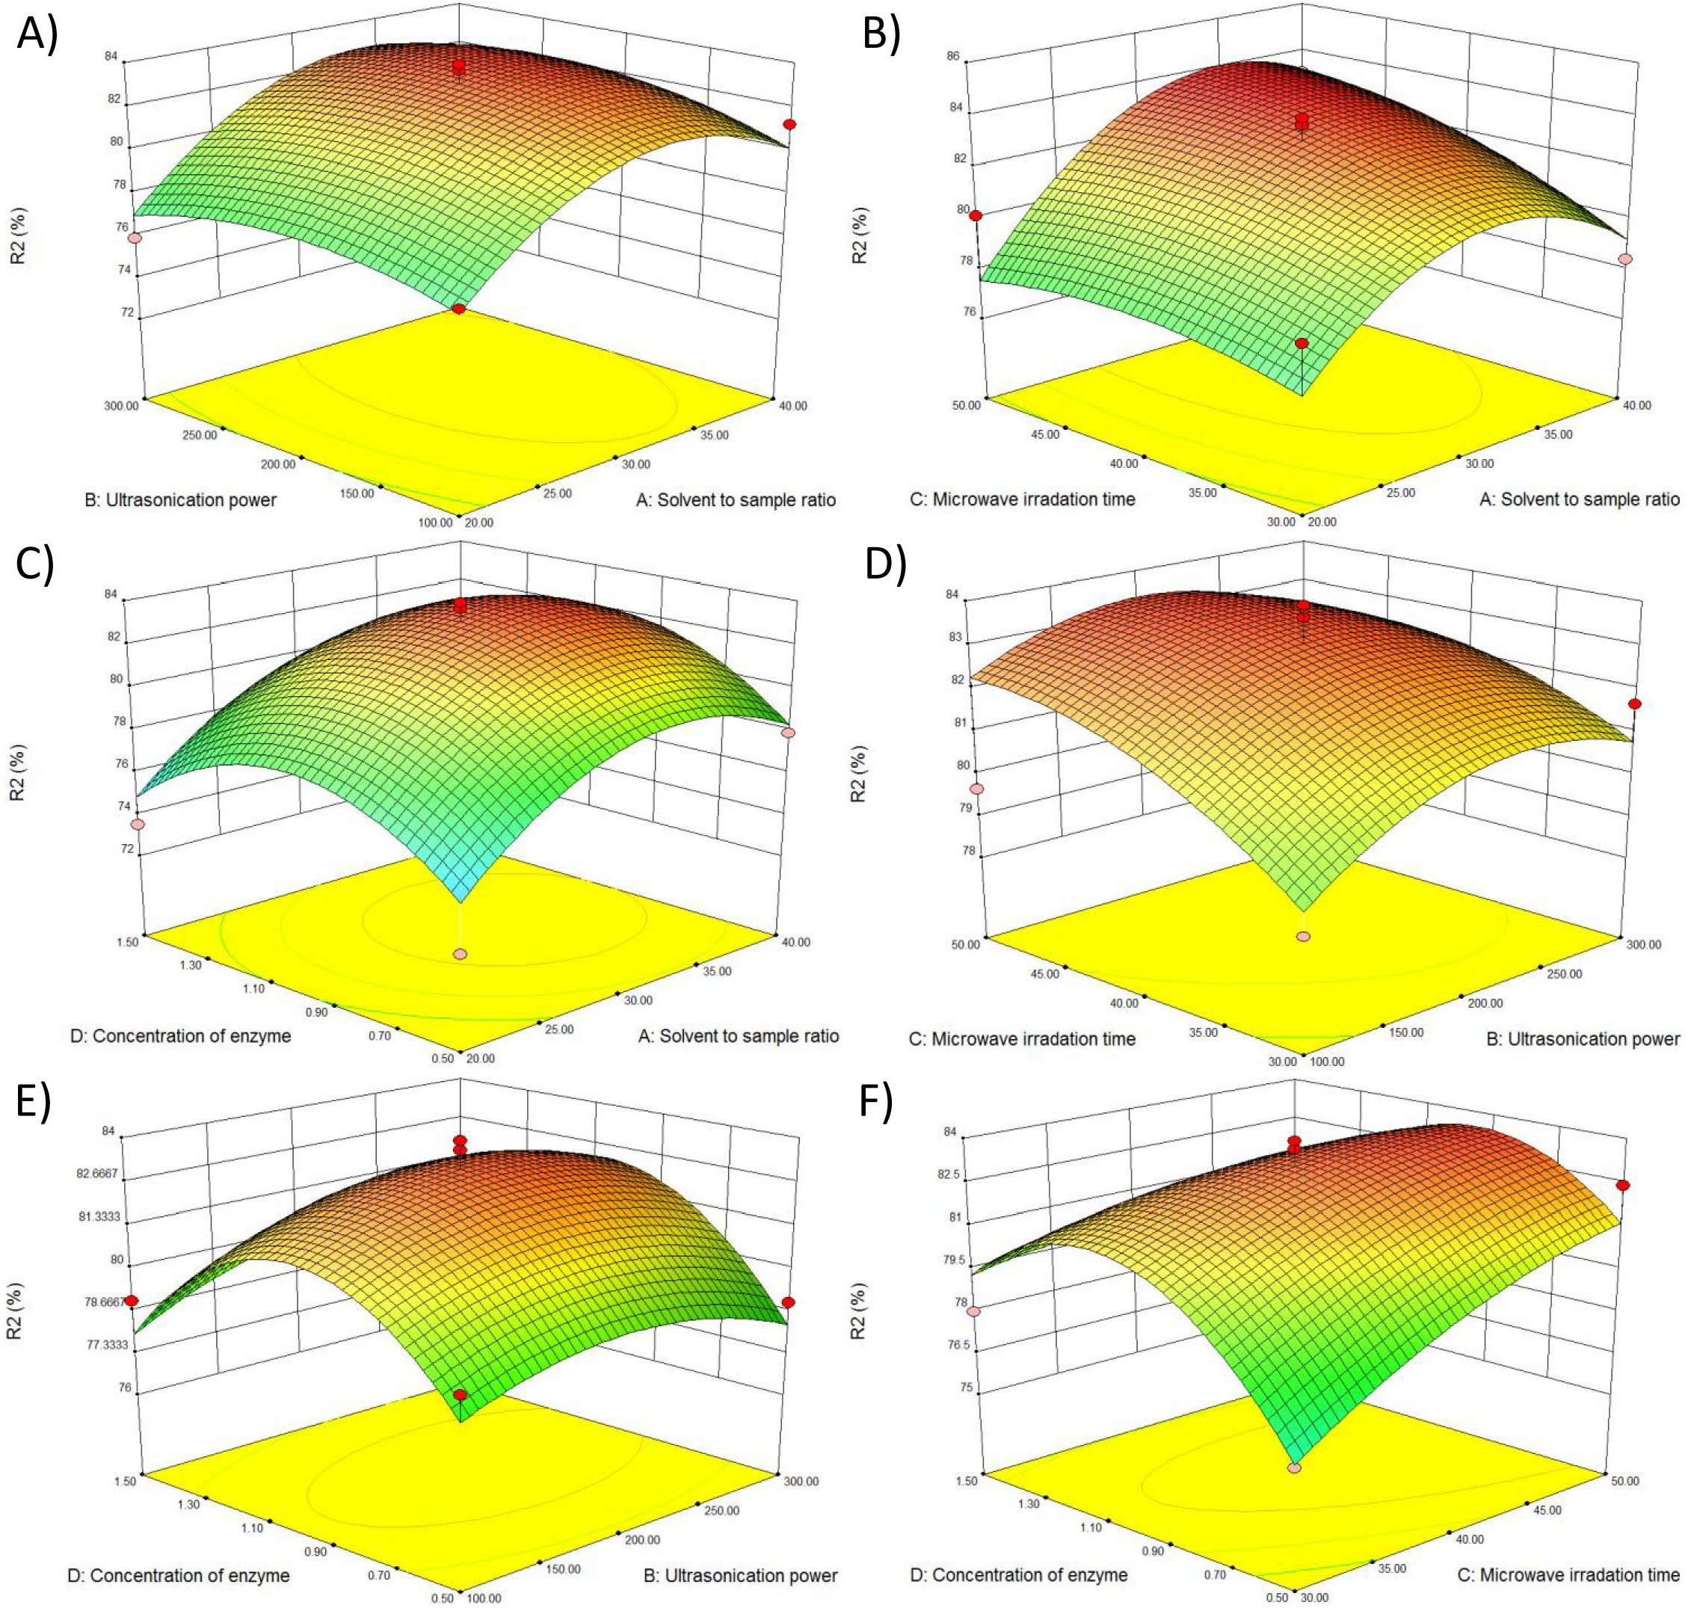
Figure S2. Response surface analysis for different extraction parameters. Response surface (3D) showing the interaction effects of the ultrasonication power, microwave irradiation time, solvent to sample ratio and enzyme concentration on the biological activity of extracted species, respectively. The levels of confined parameters are ultrasonication power as 200 W, microwave irradiation time as 40 s, solvent to raw material ratio as 30 and concentration of enzyme as 1 mg/mL, respectively.
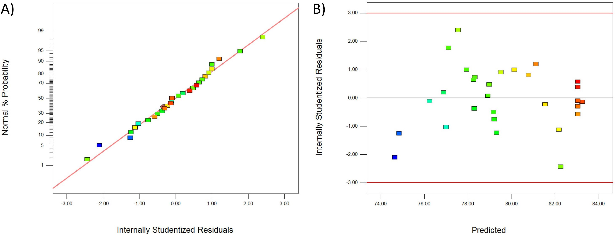
Figure S3. Model adequacy checking analysis. Normal probability of internally studentized residuals (A) and the plot of internally studentized residuals vs. predicted response of biological activity (B) for the biological activity of extracted curcumin species, respectively.
Table S1. The design and experimental results of the orthogonal experiment.
No. | A (W) | B  (s) | C (W) | D (min) | E (mg/ml) | F (min) | G | R1 (%) | R2 (%)
1 | 462 | 20 | 100 | 5 | 1 | 20 | 10 | 2.47 | 72.06
2 | 462 | 30 | 200 | 12.5 | 2 | 30 | 20 | 2.67 | 77.5
3 | 462 | 40 | 300 | 20 | 3 | 40 | 30 | 2.72 | 78.85
4 | 595 | 20 | 100 | 12.5 | 2 | 40 | 30 | 2.46 | 71.39
5 | 595 | 30 | 200 | 20 | 3 | 20 | 10 | 2.49 | 72.89
6 | 595 | 40 | 300 | 5 | 1 | 30 | 20 | 2.68 | 77.56
7 | 700 | 20 | 200 | 5 | 3 | 30 | 30 | 2.71 | 79
8 | 700 | 30 | 300 | 12.5 | 1 | 40 | 10 | 2.76 | 80.69
9 | 700 | 40 | 100 | 20 | 2 | 20 | 20 | 2.75 | 79.56
10 | 462 | 20 | 300 | 20 | 2 | 30 | 10 | 2.65 | 76.85
11 | 462 | 30 | 100 | 5 | 3 | 40 | 20 | 2.49 | 72.54
12 | 462 | 40 | 200 | 12.5 | 1 | 20 | 30 | 2.82 | 80.98
13 | 595 | 20 | 200 | 20 | 1 | 40 | 20 | 2.77 | 80.79
14 | 595 | 30 | 300 | 5 | 2 | 20 | 30 | 2.84 | 82.65
15 | 595 | 40 | 100 | 12.5 | 3 | 30 | 10 | 2.49 | 72.56
16 | 700 | 20 | 300 | 12.5 | 3 | 20 | 20 | 2.48 | 72.12
17 | 700 | 30 | 100 | 20 | 1 | 30 | 30 | 2.68 | 77.87
18 | 700 | 40 | 200 | 5 | 2 | 40 | 10 | 2.72 | 78.98
Here, different experimental factors (A to G) were defined as microwave irradiation power (factor A), microwave irradiation time (factor B), ultrasonication power (factor C), ultrasonication extraction time (factor D), the concentration of pectinase (factor E), enzyme treatment time (factor F) and the ratio of solvent to raw material (factor G).
Table S2. Response surface center design (un-coded) and results for the extraction ratio (R1) and biological activity (R2) of extracted species.
Std  order | Run order | A | B | C | D | R1 % |  |  | R2 %
 |  |  |  |  |  | Actual | Predicted | Residual | Actual | Predicted | Residual
15 | 1 | 30 | 100 | 50 | 1 | 2.72 | 2.80 | -0.08 | 79.65 | 82.25 | -2.60
7 | 2 | 30 | 200 | 30 | 1.5 | 2.66 | 2.71 | -0.05 | 78.00 | 79.31 | -1.31
29 | 3 | 30 | 200 | 40 | 1 | 2.87 | 2.85 | 0.02 | 83.90 | 83.04 | 0.86
4 | 4 | 40 | 300 | 40 | 1 | 2.78 | 2.80 | -0.02 | 81.30 | 81.54 | -0.24
27 | 5 | 30 | 200 | 40 | 1 | 2.86 | 2.85 | 0.01 | 83.62 | 83.04 | 0.58
2 | 6 | 40 | 100 | 40 | 1 | 2.77 | 2.75 | 0.02 | 81.20 | 80.13 | 1.07
11 | 7 | 20 | 200 | 40 | 1.5 | 2.5 | 2.56 | -0.06 | 73.50 | 74.84 | -1.34
3 | 8 | 20 | 300 | 40 | 1 | 2.63 | 2.65 | -0.02 | 75.90 | 77.00 | -1.10
25 | 9 | 30 | 200 | 40 | 1 | 2.83 | 2.85 | -0.02 | 82.60 | 83.04 | -0.44
21 | 10 | 30 | 100 | 40 | 0.5 | 2.69 | 2.68 | 0.01 | 79.10 | 78.32 | 0.78
26 | 11 | 30 | 200 | 40 | 1 | 2.83 | 2.85 | -0.02 | 82.90 | 83.04 | -0.14
9 | 12 | 20 | 200 | 40 | 0.5 | 2.45 | 2.55 | -0.10 | 72.40 | 74.65 | -2.25
18 | 13 | 40 | 200 | 30 | 1 | 2.69 | 2.72 | -0.03 | 78.40 | 79.21 | -0.81
8 | 14 | 30 | 200 | 50 | 1.5 | 2.7 | 2.72 | -0.02 | 79.00 | 78.91 | 0.09
19 | 15 | 20 | 200 | 50 | 1 | 2.75 | 2.65 | 0.10 | 80.12 | 77.55 | 2.57
5 | 16 | 30 | 200 | 30 | 0.5 | 2.64 | 2.62 | 0.02 | 76.12 | 76.24 | -0.12
10 | 17 | 40 | 200 | 40 | 0.5 | 2.71 | 2.71 | 0.00 | 77.90 | 78.29 | -0.39
13 | 18 | 30 | 100 | 30 | 1 | 2.67 | 2.69 | -0.02 | 78.64 | 79.18 | -0.54
16 | 19 | 30 | 300 | 50 | 1 | 2.78 | 2.83 | -0.05 | 80.98 | 82.18 | -1.20
12 | 20 | 40 | 200 | 40 | 1.5 | 2.75 | 2.72 | 0.03 | 79.49 | 78.98 | 0.51
6 | 21 | 30 | 200 | 50 | 0.5 | 2.84 | 2.79 | 0.05 | 82.40 | 81.12 | 1.28
20 | 22 | 40 | 200 | 50 | 1 | 2.87 | 2.87 | 0.00 | 83.10 | 83.24 | -0.14
14 | 23 | 30 | 300 | 30 | 1 | 2.77 | 2.76 | 0.01 | 81.65 | 80.78 | 0.87
23 | 24 | 30 | 100 | 40 | 1.5 | 2.68 | 2.64 | 0.04 | 79.01 | 77.94 | 1.07
28 | 25 | 30 | 200 | 40 | 1 | 2.86 | 2.85 | 0.01 | 82.19 | 83.04 | -0.85
24 | 26 | 30 | 300 | 40 | 3 | 2.79 | 2.74 | 0.05 | 80.49 | 79.51 | 0.98
17 | 27 | 20 | 200 | 30 | 1.5 | 2.69 | 2.62 | 0.07 | 79.01 | 77.11 | 1.90
22 | 28 | 30 | 300 | 40 | 0.5 | 2.71 | 2.69 | 0.02 | 78.95 | 78.26 | 0.69
1 | 29 | 20 | 100 | 40 | 1 | 2.6 | 2.58 | 0.02 | 77.10 | 76.89 | 0.21
A, B, C and D are the ratio of solvent to sample, the ultrasonication power (W), the microwave irradiation time (s) and the concentration of pectinase (mg/mL), respectively.
Table S3. Variable analysis for the fitted models of the extraction ratio (R1) and biological activity (R2) of extracted species.
 | Source | Sum of  Squares | DF | Coefficient | Mean  Square | F value | p-value  Prob > F
R1 | Model | 0.25 | 14 |  | 0.018 | 4.86 | 0.0027
R1 | Residual | 0.051 | 14 |  | 0.004
R1 | Lack of Fit | 0.050 | 10 |  | 0.005 | 14.28 | 0.0103
R1 | Pure Error | 0.001 | 4 |  | 0.0004
R1 | Cor Total | 0.301 | 28
R1 | Mean |  |  | 2.73
R1 | R² |  |  | 0.829
R1 | Adj R² |  |  | 0.659
R1 | Pred R² |  |  | 0.037
R1 | C.V. % |  |  | 2.22
R1 | PRESS |  |  | 0.29
R1 | Std. Dev |  |  | 0.061
R2 | Model | 186.16 | 14 |  | 13.30 | 4.84 | 0.0028
R2 | Residual | 38.45 | 14 |  | 2.75
R2 | Lack of Fit | 36.44 | 10 |  | 3.64 | 7.25 | 0.0357
R2 | Pure Error | 2.01 | 4 |  | 0.50
R2 | Cor Total | 224.61 | 28
R2 | Mean |  |  | 79.61
R2 | R² |  |  | 0.829
R2 | Adj R² |  |  | 0.658
R2 | Pred R² |  |  | 0.0516
R2 | C.V. % |  |  | 2.08
R2 | PRESS |  |  | 213.03
R2 | Std. Dev |  |  | 1.66
DF: degree of freedom

